

**Name: Muhammad Fahad**

**Sap ID: 37125**

**Section: BSCS-5A**

**Course: Computer Networking**

**Lab task# 3 & 4**

Instructor: M. Sameer Sohail

**LAB#3**

**Exercise Questions:**

• Use packet tracer to create the topology which has 3 PC’s and 3 Servers and 2 switch.

• Configure the devices using the following IP addresses and subnet masks:

|  |  |  |
| --- | --- | --- |
| Device IP | Address | Subnet mask |
| PC1 | 192.168.1.1 | 255.255.255.0 |
| PC3 | 192.168.1.2 | 255.255.255.0 |
| PC4 | 192.168.1.3 | 255.255.255.0 |
| Server1 | 192.168.1.4 | 255.255.255.0 |
| Server2 | 192.168.1.5 | 255.255.255.0 |
| Server3 | 192.168.1.6 | 255.255.255.0 |
| LAN 1 interface | 192.168.1.10 | 255.255.255.0 |
| LAN 2 interface |  | 255.255.255.0 |

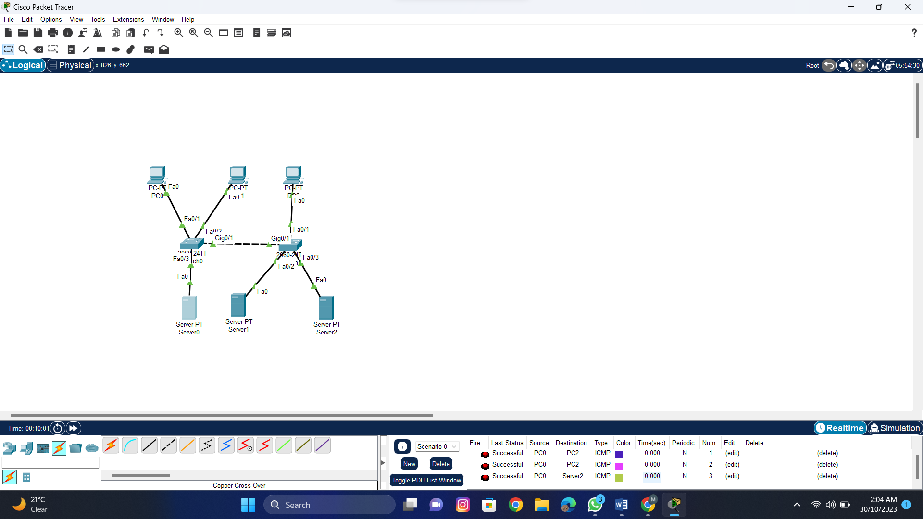

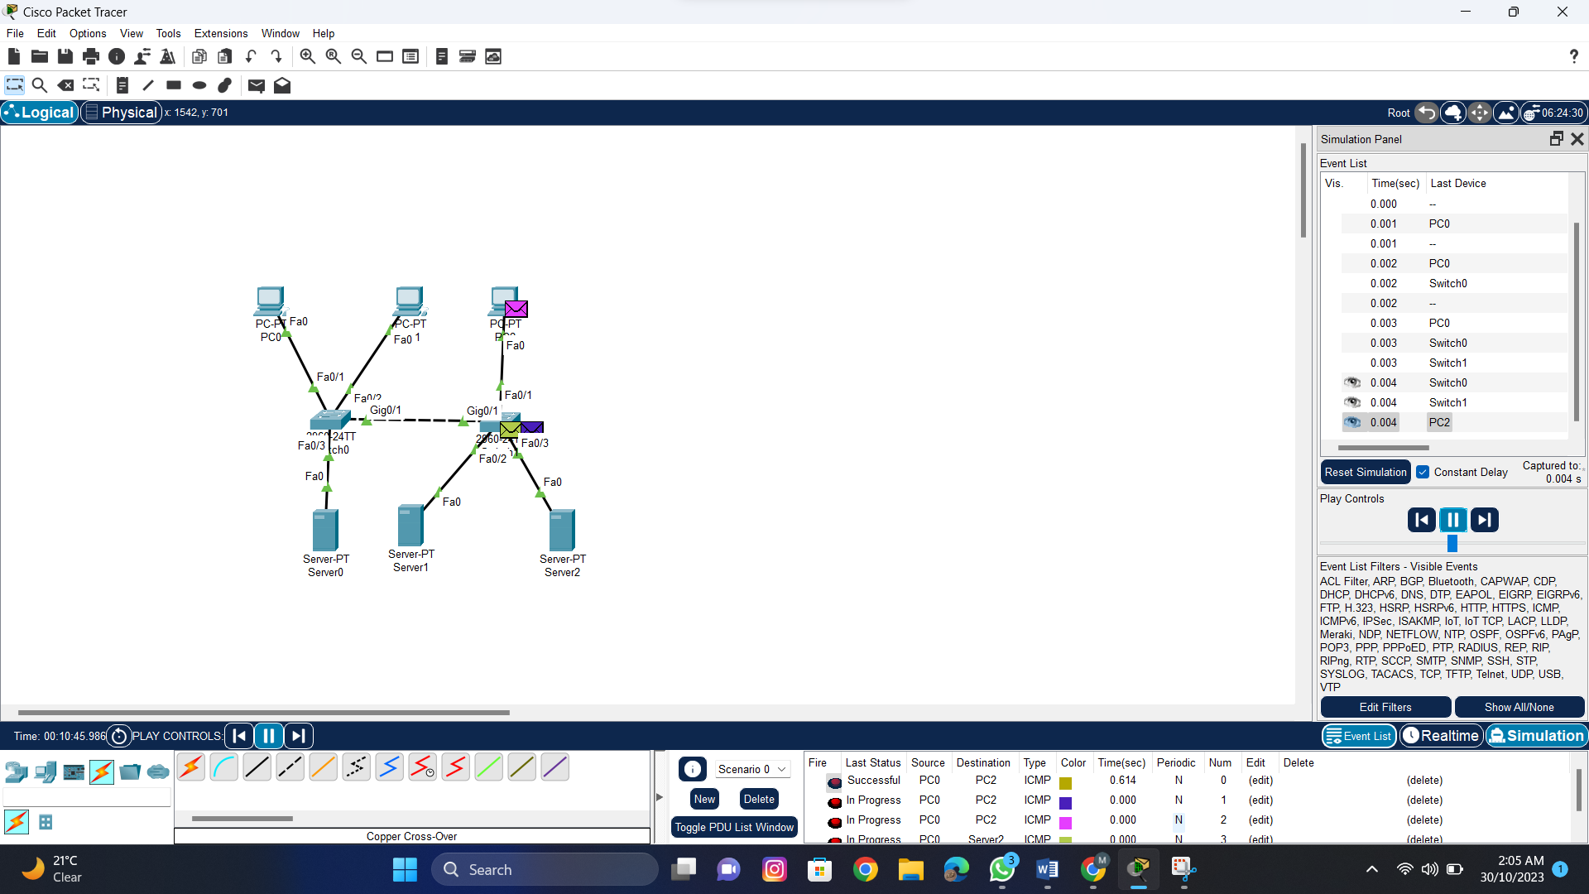

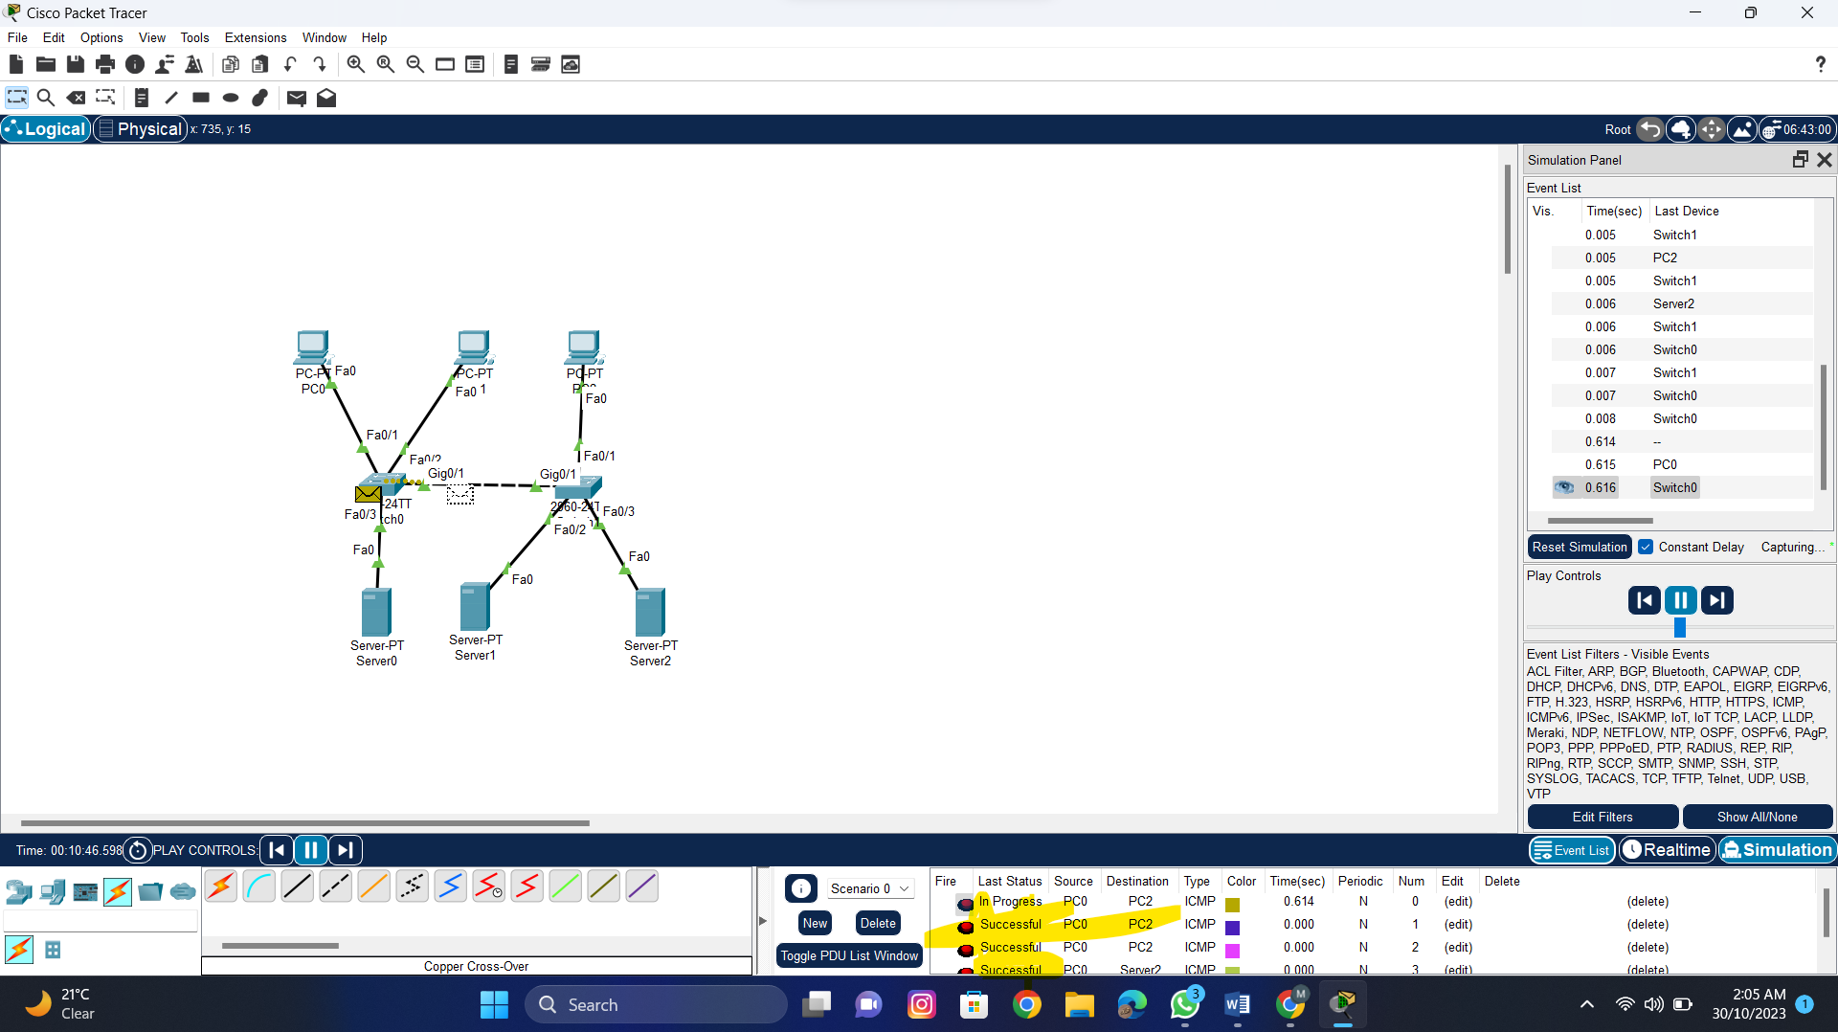

**LAB#4**

**OBJECTIVES:**

1. Concept Builder Lab: Hub and Switch Usage

2. To become familiar with Packet Tracer

|  |  |  |  |
| --- | --- | --- | --- |
| **Lab Performance** | | | |
| **No.** | **Title** | **Marks** | **Obtained**  **Marks** |
| **1** | **Ability to Solve Problems** | **10** |  |
| **2** | **Implementation of skills** | **10** |  |

**Remarks (if any): ………………………………….**

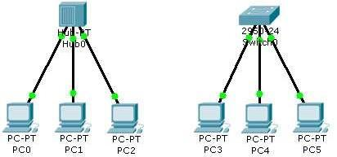

**Scenario**

These topologies represent the simplest hub-based and switch-based networks, ideal for studying the different processes between hubs and switches.

**Step 1**

Add a generic hub and three generic PCs and arrange them as shown in the image.

Add a 2950-24 switch and three generic PCs and arrange them as shown in the image.

**Step 2**

Connect the devices as shown in the image. Use the appropriate connection type for each link.

**Step 3**

Set the IP address and subnet mask for the PCs as follows:

|  |  |  |
| --- | --- | --- |
| **PC** | **IP Address** | **Subnet Mask** |
| PC0 | 192.168.1.1 | 255.255.255.0 |
| PC1 | 192.168.1.2 | 255.255.255.0 |
| PC2 | 192.168.1.3 | 255.255.255.0 |
| PC3 | 192.168.2.1 | 255.255.255.0 |
| PC4 | 192.168.2.2 | 255.255.255.0 |
| PC5 | 192.168.2.3 | 255.255.255.0 |

**Step 4**

If all connections and addressing are correct, the link lights should be green. If not, troubleshoot the cabling type, connections, and addressing.

**Reflect:**

1) Go to Simulation mode. In the Event List filters, enable only ICMP and ARP. Using the “Simple PDU”, issue a ping from PC0 to PC1. Play the simulation. Pay close attention to how the hub processes the ICMP and ARP packets. After that, once again, use”Add Simple PDU” to issue a ping from PC1 to PC0. Play the simulation again. How has the behavior of the hub changed from the first and second ping attempts, if at all?

2) Still in Simulation mode, in the Event List Filters, enable only ICMP and ARP. Using “Add Simple PDU”, issue a ping from PC3 to PC4. Play the simulation. Pay close attention to how the switch processes the ICMP and ARP packets. After that, once again, use “Add Simple PDU” to issue a ping from PC4 to PC3. Play the simulation again. How has the behavior of the switch changed from the first and second ping attempts, if at all? In what ways did the switch process the packets similarly or differently from the hub between the first and second ping attempts?

**For the switched based network, set the new IP address and subnet mask for the PCs as follows:**

|  |  |  |
| --- | --- | --- |
| **PC** | **IP Address** | **Subnet Mask** |
| PC0 | 192.168.1.36 | 255.255.255.224 |
| PC1 | 192.168.1.37 | 255.255.255.224 |
| PC2 | 192.168.1.38 | 255.255.255.224 |
| PC3 | 192.168.1.91 | 255.255.255.224 |

If all connections and addressing are correct, the link lights should be green. If not, troubleshoot the cabling type, connections, and addressing.

**In this scenario all computers are communicated or not…? If not, what is the reason?**

**TASK:**

Send a ping command for both HUB and SWITCH network using command prompt Packet Tracer and notice the results in Simulation mode.

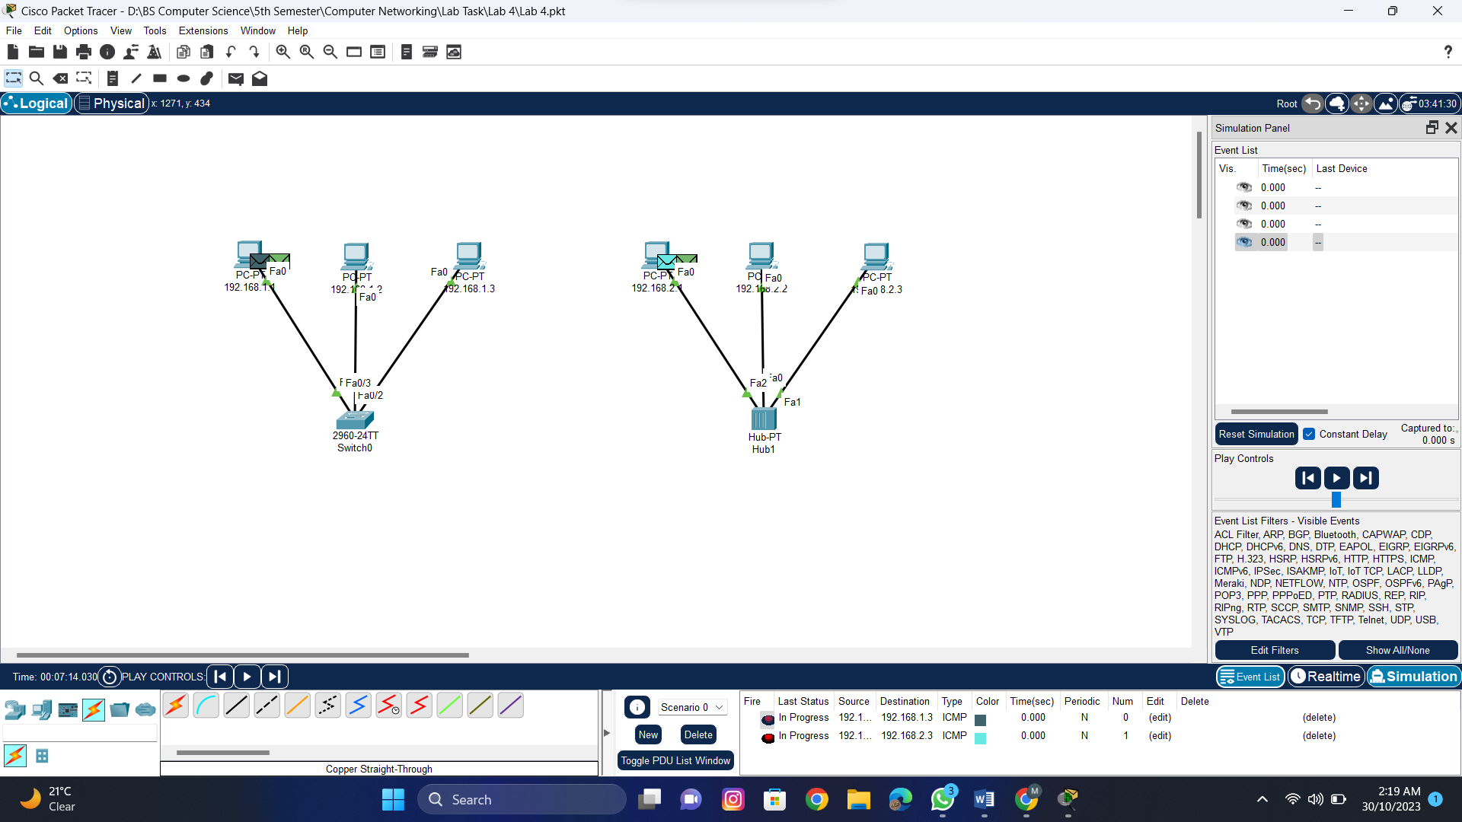

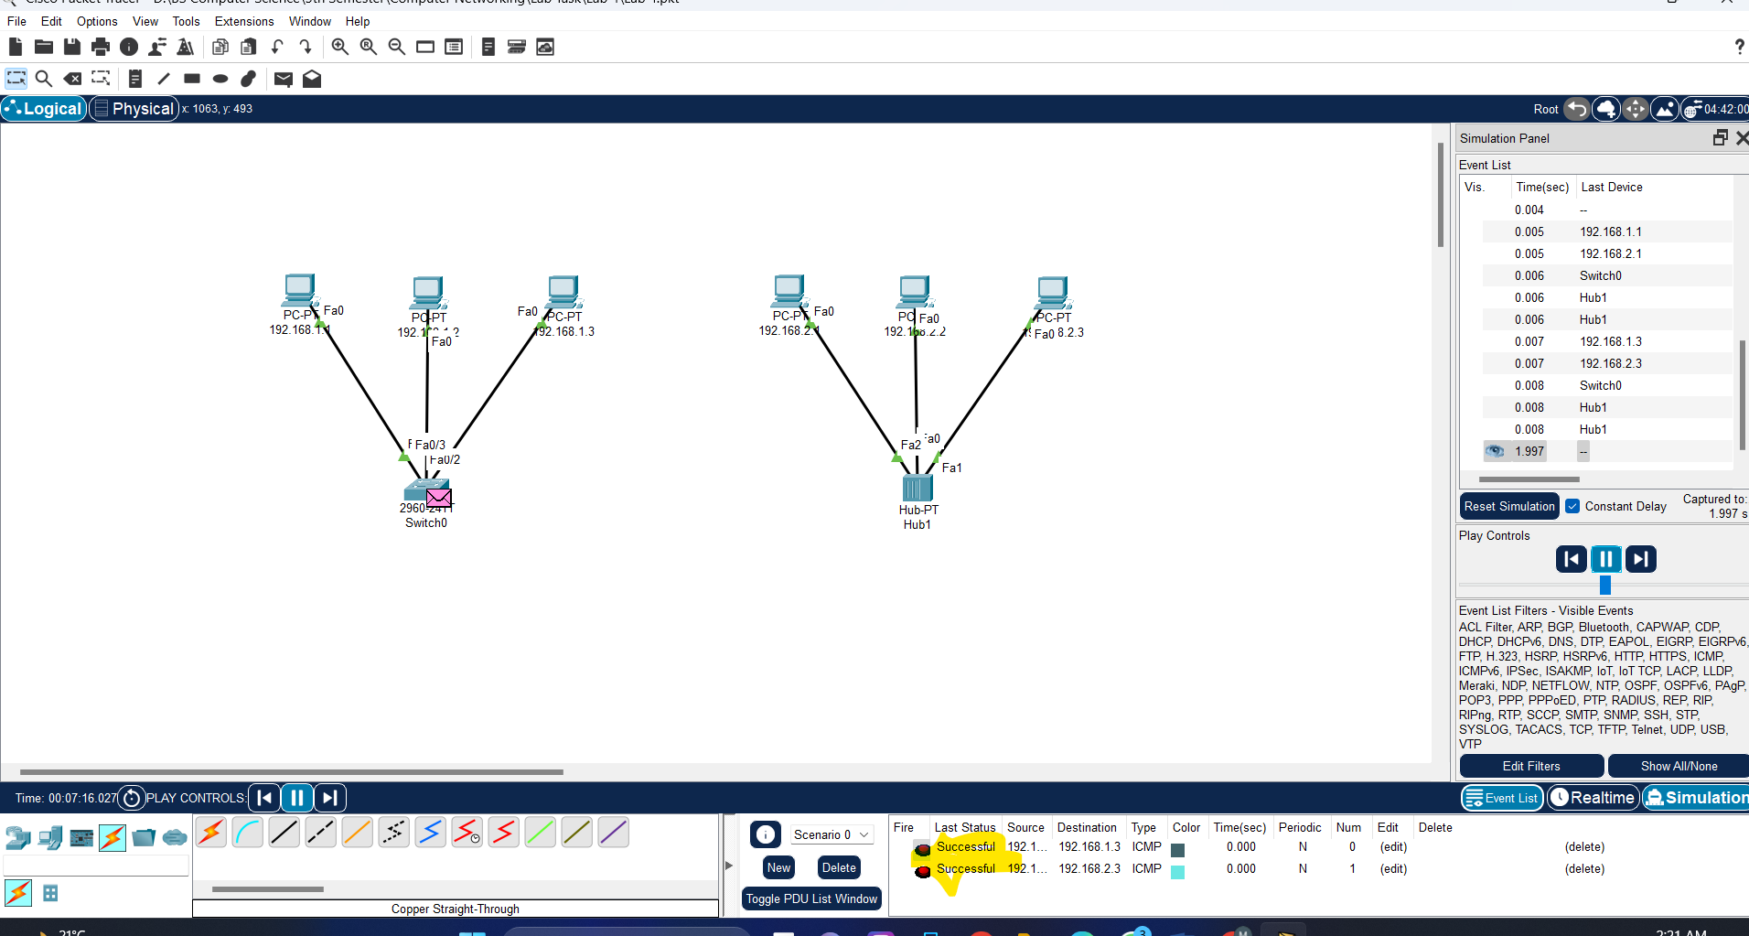

Switch Ping

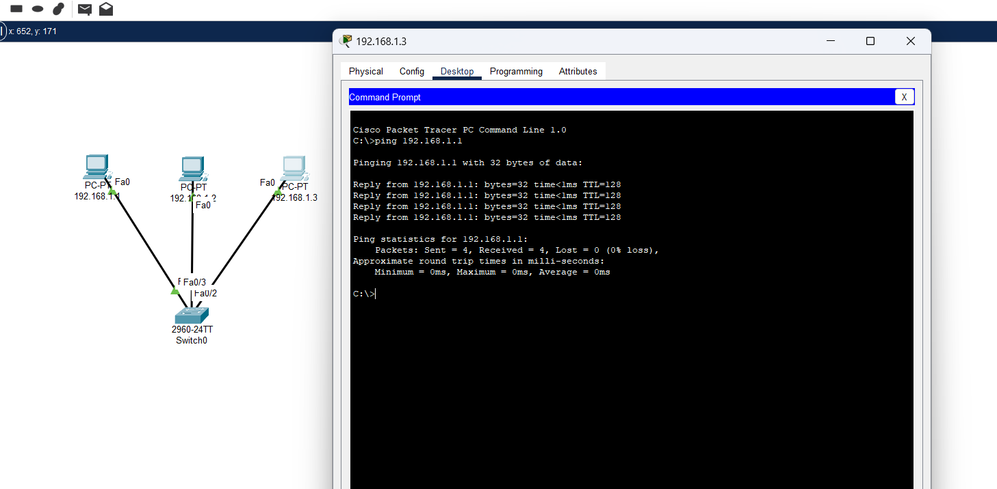

Hub Ping

